**Ch5-HSD-OneMany**

**Homework:** Chapter 5 Heather Sweeney Designs One-to-Many Relationships - Due ___ ___ __ Before Class

* Note: The Heather Sweeney (HSD) lessons, tutorials, and assignments use a simpler/older version than shown in the current textbook. The most significant difference is the identifier of the CONTACT entity.

**One-to-Many (1:N) Relationships:** Create a relational database design from the following data model:

* This includes the CUSTOMER, CONSULTING_PROJECT, and DAILY_PROJECT_HOURS entities and relationships in the E-R diagram from assignment Ch4-HSDProject.

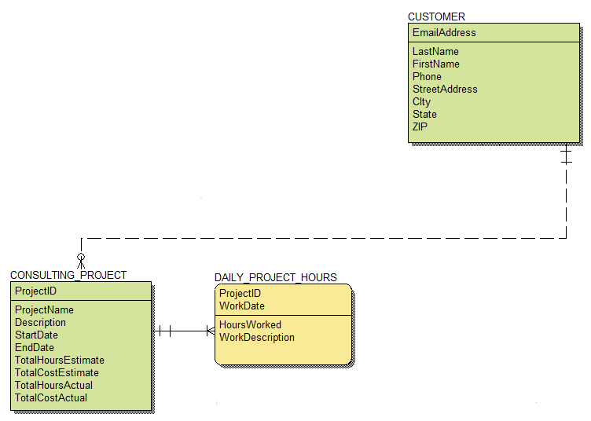

**Database Design:**

* Write the definitions of the tables using the format TABLE (Column1, Column2, ...).
* Underline the primary key in each table, and italicize the foreign keys.
* Write the referential integrity check for each foreign key.

**SQL and QBE Queries:** Create the following SQL and QBE queries in your HSD.accdb Access database:

* **SQLQuery-A and QBEQuery-A:** Display all the customer and project information for each project (but not including the daily hours).
* **SQLQuery-B and QBEQuery-B:** Display all the project and daily hours information (but not including the customers).
* **SQLQuery-C and QBEQuery-C:** Display all the customer, project, and daily hours information.